LeetCode Program 9
Link :- https://leetcode.com/problems/palindrome-number/

Successful Submission
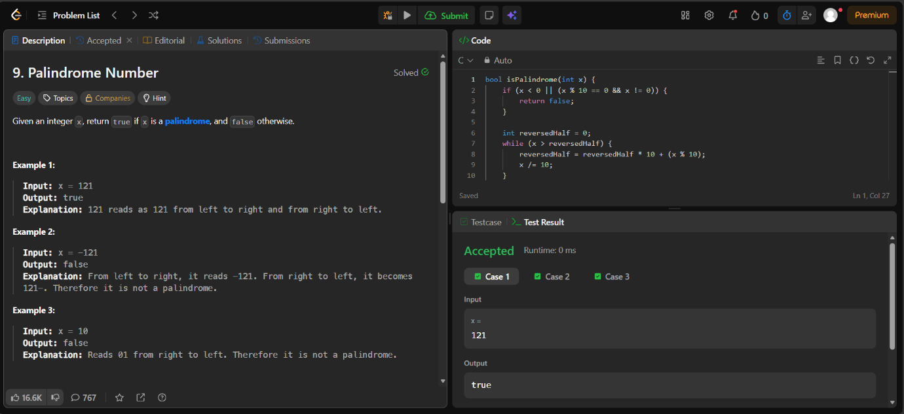
Source Code


